Question 1 — Choose the Right Genomic Assay
Problem. Gene X is significantly upregulated in a disease group relative to healthy controls. Candidate mechanisms: a regulatory variant, altered chromatin accessibility, altered transcription-factor (TF) binding or histone modification, altered DNA methylation, or altered enhancer–promoter contact.

1. My reasoning before AI
First assay: ATAC-seq (case and control, ≥ 2 biological replicates each), run in parallel with WGS on the same individuals.
My reasoning is that the five candidate mechanisms are not five independent hypotheses of equal prior probability — they are mostly nested, and they converge on chromatin accessibility. A regulatory variant that matters usually alters TF binding; altered TF binding usually alters nucleosome occupancy; loss of promoter or enhancer methylation usually accompanies opening; and an enhancer that newly contacts the promoter is usually accessible. Accessibility is therefore the layer with the highest probability of showing a signal per unit of cost and input material, and — more importantly — it is the layer that nominates a specific genomic interval. Without a nominated interval, every other assay is a genome-wide fishing expedition; with one, ChIP/CUT&Tag, WGBS and Hi-C all become targeted questions about a named coordinate.
I pair it with WGS rather than WES from the start, because the hypothesis under test is cis-regulatory and WES captures essentially none of the non-coding regulatory space. WGS is what supplies the candidate variant that any final model has to explain.
What ATAC-seq cannot do, and why I plan more than one tier: it cannot say which TF occupies an open site, it cannot say which gene an open site serves, and it cannot distinguish a cause of upregulation from a consequence of it. That last limitation applies to every assay in this list, and it is why the strategy has to end in perturbation rather than in correlation.
My planned order, before any AI input: (0) confirm the phenotype and locate the promoter with RNA-seq, adding CAGE/RAMPAGE if a TSS switch is plausible; (1) ATAC-seq + WGS; (2) H3K27ac and H3K4me1 CUT&Tag plus WGBS/EM-seq at the nominated element; (3) Micro-C to test whether the element contacts the Gene X promoter; (4) MPRA for the allele and CRISPRi for the element.

2. AI-assisted workflow
I asked the model to attack the design rather than to produce one. The prompt was written so that agreement was not an acceptable answer:
ROLE: act as a sceptical reviewer for a regulatory-genomics grant panel.

MY DESIGN (do not rewrite it, critique it):
Gene X is up in disease vs control. Tier 0 RNA-seq (+CAGE); Tier 1 ATAC-seq
+ WGS; Tier 2 H3K27ac/H3K4me1 CUT&Tag + EM-seq at the nominated element;
Tier 3 Micro-C; Tier 4 MPRA (ref vs alt allele) and CRISPRi of the element.

TASKS:
1. Name the single weakest inferential step and say what result would
falsify my model at that step.
2. For each assay, state one claim it CANNOT support that people routinely
make with it. Cite a primary paper for each.
3. Give the cheapest experiment that would kill the whole model early.
4. Say which assay I could drop without losing discriminating power.
5. Flag any place where my ordering assumes the conclusion.

CONSTRAINTS: no generic pipeline advice; every criticism must name the
specific inference it attacks. If you cannot support a claim, say so.
The four criticisms I judged worth acting on:
1. Direction of causality is assumed in Tier 1. Accessibility differences in disease tissue may be a consequence of the disease state (different cell-type proportions, different activation state), not a cause of Gene X upregulation. Action taken: I added cell-composition control to the design — sorted or single-cell-resolved input where possible — and I state this limitation explicitly rather than hiding it.
2. H3K27ac was doing too much work in my Tier 2. I had been treating H3K27ac as evidence of enhancer activity. The model challenged this and I verified it (see below): H3K27ac is a strong correlate of enhancer activity but is not required for it. Action taken: H3K27ac was demoted from "evidence of function" to "evidence of state".
3. Micro-C is the most expensive and the least decisive tier. Contact frequency is largely pre-existing and survives acute loss of the machinery that creates loops. Action taken: Micro-C stays, but as a hypothesis-generating step for choosing CRISPRi targets, not as evidence of regulation; if budget were constrained this is the tier I would drop.
4. MPRA answers a different question from the one I was asking. MPRA tests whether a sequence can drive transcription in a reporter context, not whether it does so in its native chromatin. Action taken: MPRA is retained only for the allele comparison (ref vs alt), with CRISPRi as the test of the element in situ.
One AI suggestion I rejected: it proposed adding a TF ChIP-seq panel before knowing which motif is disrupted. That is an unbounded search — there are >1,600 human TFs — and the motif analysis of the ATAC/WGS result should come first and nominate the candidate factor.

3. Verification
Each recommendation that survived was checked against a primary or standards source. Where the sources disagreed, I report the disagreement rather than resolving it artificially.
Claim being checked | Authoritative source consulted | Outcome
ATAC-seq depth and quality targets are achievable for a two-condition design | ENCODE4 ATAC-seq data standards (encodeproject.org/atac-seq/) | Confirmed and made concrete: ≥ 50 M non-duplicate, non-mitochondrial paired-end reads per replicate; TSS enrichment > 7 ideal on GRCh38 (5–7 acceptable); FRiP > 0.3 (> 0.2 acceptable); ≥ 2 biological replicates with IDR rescue and self-consistency ratios < 2. These are now the acceptance criteria in my design.
H3K27ac demonstrates that an element is an active enhancer | Creyghton 2010 PNAS; Rada-Iglesias 2011 Nature (origin of the mark); Zhang T. et al. 2020 Genome Biology 21:45 (H3.3-K27R mutant mESCs); Raisner 2018 Cell Reports (opposing evidence) | REVISED. H3K27ac separates active from poised enhancers, but removing nearly all enhancer H3K27ac in H3.3-K27R mESCs leaves the transcriptome largely undisturbed; Raisner et al. argue the opposite from p300/CBP bromodomain inhibition. The honest reading is that H3K27ac is a correlate of p300/CBP activity, not a demonstrated causal intermediate. My figure and text now say "chromatin state", not "activity".
Histone ChIP-seq needs a matched control and defined depth | ENCODE4 histone ChIP-seq standards (encodeproject.org/chip-seq/histone-encode4/) | Confirmed: an input control experiment with matching run type and replicate structure is required; 20 M usable fragments per replicate for narrow marks (H3K27ac is classed narrow), 45 M for broad marks (H3K4me1 is classed broad — the opposite of what I had assumed).
CUT&Tag can simply replace ChIP-seq for H3K27ac | Kaya-Okur 2019 Nat Commun 10:1930; Kaya-Okur 2020 Nat Protoc; Abbasova 2025 Nat Commun 16:2993 | PARTLY REVISED. CUT&Tag gives usable profiles from far fewer cells and reads and uses an IgG/no-primary control plus carry-over E. coli DNA for calibration, but it recovers on average only ~54% of ENCODE ChIP-seq acetylation peaks, biased towards accessible, strongly enriched sites. For discovery I keep ChIP-seq or accept the recall limitation explicitly.
Bisulfite/EM-seq methylation calls are unambiguous | Vaisvila 2021 Genome Research 31:1280 (EM-seq); Huang 2010 PLoS ONE; Nestor 2010 BioTechniques | REVISED. EM-seq fixes the DNA-damage and GC-bias problems of bisulfite, but neither method distinguishes 5mC from 5hmC — oxBS-seq or TAB-seq is required for that. The figure now says "cytosine modification", not "methylation".
3D contact between element and promoter is evidence of regulation | Rao 2017 Cell (RAD21 degron); Hsieh 2022 Nat Genet 54:1919; Alexander 2019 eLife 8:e41769 | REVISED. Enhancer–promoter interactions and transcription are largely maintained after acute loss of CTCF, cohesin, WAPL or YY1, and live imaging shows enhancer-dependent Sox2 transcription without enhancer proximity. Contact is now a targeting heuristic in my design, not evidence.
MPRA measures enhancer activity | Inoue 2017 Genome Research 27:38 | QUALIFIED. Episomal and chromosomally integrated versions of the same library give substantially different activity measurements, so MPRA measures sequence potential in a defined context, not native-locus activity.
CRISPRi is element-specific | Fulco 2016 Science; Fulco 2019 Nat Genet (ABC); Gasperini 2019 Cell; Lensch 2022 eLife 11:e75115 | QUALIFIED. CRISPRi mapping of enhancer–promoter connections is well established, but KRAB-mediated silencing spreads: H3K9me3 extends tens of kilobases and can silence a neighbouring gene across a 5 kb spacer. Distance-matched control sgRNAs and a neighbouring-gene read-out are now mandatory parts of my design.

4. Final conclusion
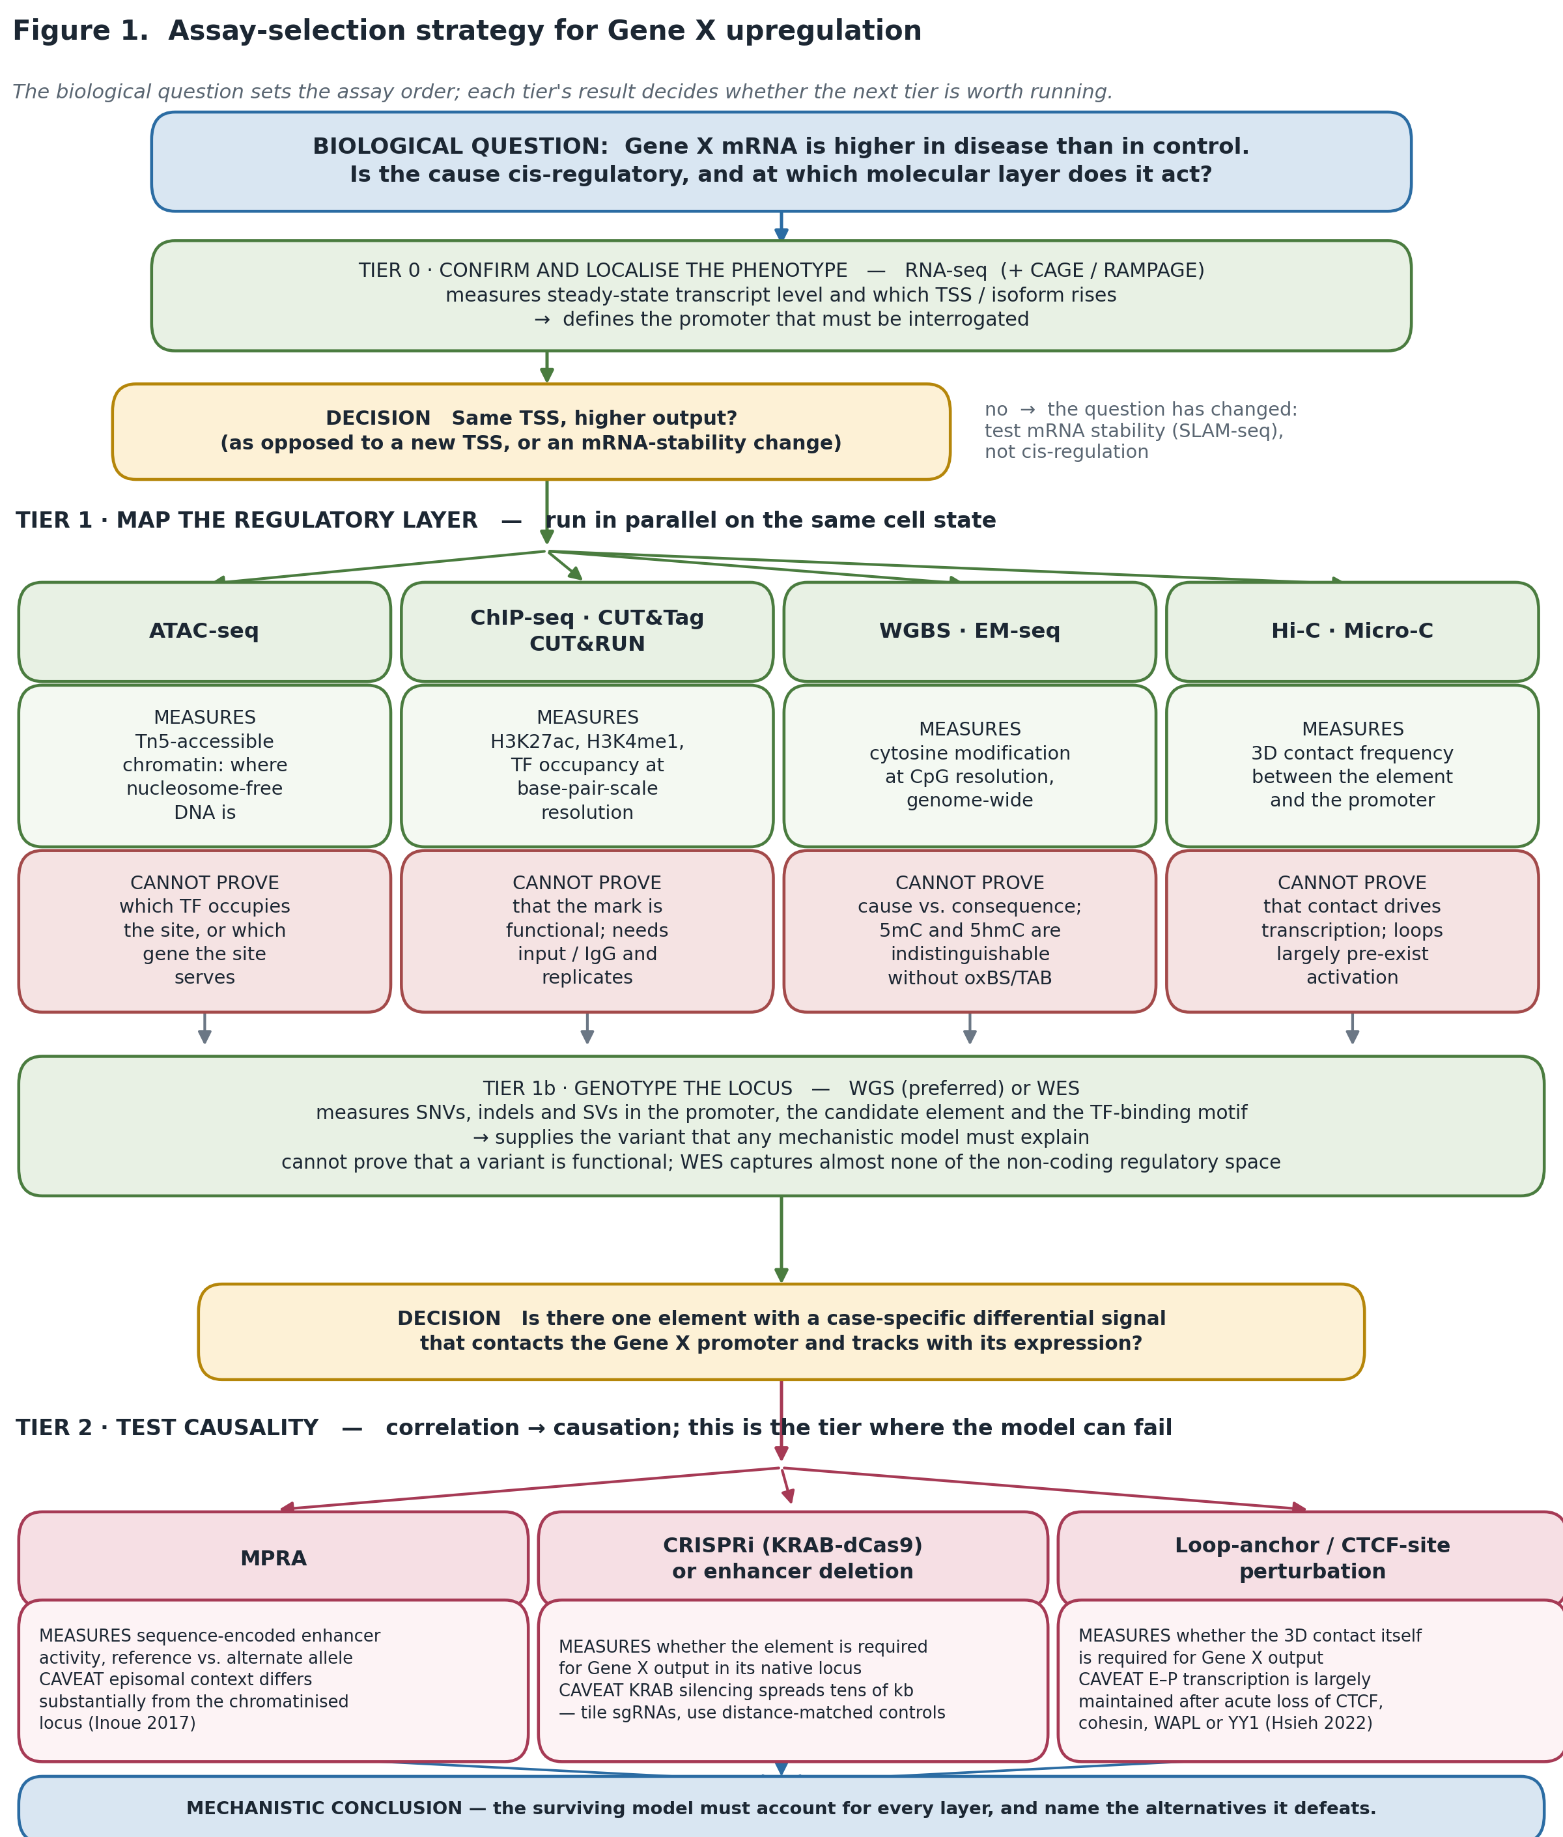
Figure 1. Assay-selection strategy. Tier 0 confirms and localises the phenotype; Tier 1 maps the regulatory layer and genotypes the locus; Tier 2 converts correlation into causation. Each assay box carries what it measures and what it cannot prove.

~200-word explanation: what each assay measures, what it cannot prove, how they complement each other
Each assay reports one physical quantity. RNA-seq measures steady-state transcript abundance; CAGE/RAMPAGE measures where transcription starts. ATAC-seq measures Tn5 accessibility — where DNA is nucleosome-free. ChIP-seq, CUT&RUN and CUT&Tag measure occupancy of a specific protein or histone modification. WGBS and EM-seq measure cytosine modification at CpG resolution. Hi-C and Micro-C measure ligation-derived contact frequency. WGS measures sequence. None of these measures function. Accessibility cannot name the transcription factor or the target gene; H3K27ac marks active enhancers but is dispensable for their activity, so it reports state rather than function; methylation cannot be assigned as cause or consequence and cannot separate 5mC from 5hmC; contact frequency largely pre-exists activation and persists after acute cohesin or CTCF loss; a variant from WGS is a candidate, not a mechanism. They complement each other by constraining different parts of one model: WGS supplies the variant, ATAC nominates the element, CUT&Tag and EM-seq describe its state, Micro-C links it to a promoter, and RNA-seq supplies the phenotype that must be explained. Only perturbation — MPRA for the allele, CRISPRi or deletion for the element — converts that chain into a causal claim.
The biological question chooses the assay because… each assay measures one physical quantity, not a mechanism, so the assay is only informative when the question has been narrowed to the layer that quantity actually reports on; running them in the order that the question dictates turns each result into the argument for the next experiment, whereas running them in parallel without a question yields correlations that no amount of data can promote into causation.

Question 2 — From FASTQ to a Trustworthy Analysis Workflow

1. My reasoning before AI
My own workflow, written before prompting, and the purpose of each step:
Step | Purpose — why this step exists | Output / checkpoint
1. FASTQ quality control | Decide whether the library is usable at all, and discover what has to be corrected before anything downstream can be trusted. QC is read against the assay: high duplication is alarming in WGS and normal in a deeply sequenced RNA-seq library. | FastQC + MultiQC HTML; a go/no-go decision
2. Reference genome selection | Fix the coordinate system for every downstream file. If the build is not declared, coordinates, annotations and databases silently disagree — which is precisely the failure mode present in the Question 4 table. | GRCh38 no-ALT analysis set + GENCODE GTF; build and release recorded
3. Alignment | Place reads on that coordinate system with an aligner suited to the molecule: DNA reads are contiguous, RNA reads are spliced, ATAC reads are short and Tn5-shifted. | Coordinate-sorted BAM with complete @RG lines; mapping-rate check
4. Mapped-read processing | Remove or model the artefacts that alignment introduces or exposes: PCR duplicates, systematic base-quality error, contamination, coverage dropout. | Analysis-ready BAM/CRAM; depth, duplicate and contamination metrics
5. Assay-specific downstream analysis | Turn reads into the measurement the experiment was for — variants (WGS), counts (RNA-seq), peaks (ATAC/ChIP). | VCF / count matrix / peak set
6. Annotation | Attach biological and population meaning to the raw coordinates, in the same build, with the transcript named. | Annotated VCF/TSV with MANE transcript, HGVS, gnomAD and ClinVar fields
7. Visualisation | Look at the evidence directly. Most false positives are visible in a pile-up and invisible in a table. | IGV screenshots per reported locus; MultiQC report
8. Interpretation | State what the data support, what they cannot distinguish, and which experiment would distinguish it. | Written claim with its limitations attached

2. AI-assisted workflow (plan-first prompt)
I used a plan-first prompt: the model was required to produce a plan, its assumptions and its uncertainties before writing a single command, so that I could audit the reasoning rather than debug the code.
STAGE 1 — PLAN ONLY. Do not write any commands yet.

Input: paired-end Illumina FASTQ, human sample S01_CTRL_WGS, 2x80 bp,
manifest says WGS, control. Goal: raw reads -> interpretable germline
variants, single sample, reproducible.

Produce:
(a) an ordered step list; for each step state its PURPOSE, its INPUT and
OUTPUT file format, and the QC metric that decides whether to proceed;
(b) every ASSUMPTION you are making about the data that I have not told
you (read length, coverage, library prep, single vs cohort);
(c) the three decisions in this workflow that would most change the final
variant list, and the alternatives for each;
(d) for each tool you name, the exact documentation page I should check.

STAGE 2 — only after I approve the plan, emit commands, with version pins
and a one-line justification for every non-default parameter.

Rules: if a recommendation depends on information you do not have, ask
instead of assuming. Do not give me a pipeline you cannot justify.
The plan-first framing paid for itself immediately: in part (b) the model assumed a cohort callset and 30× coverage, neither of which is true here, and that assumption is what produced the VQSR recommendation I later rejected.

3. Verification

3.1 FastQC interpretation — seven modules read from the S01 snapshot
The assignment requires at least four metrics; I interpret all seven in the snapshot, because the informative part is how they corroborate one another. Values are quoted from data/demo_fastq/fastqc_snapshot.tsv.
FastQC module | Snapshot status and value | My interpretation | Action
Per base sequence quality | WARN — 3′ median Phred ≈ 12 after cycle 50 on ~15% of R1 | A late-cycle quality decay confined to a minority of reads. Per the Babraham documentation this module warns when the lower quartile falls below 10 or the median below 25, so a median of ~12 at the 3′ end is a real degradation, not cosmetic. Because it is late-cycle and partial, it is consistent with normal chemistry decay plus the adapter read-through seen below, rather than an instrument failure. | Trim 3′ ends; do not over-trim — BQSR models exactly these low-quality cycles and removing them first destroys the information it needs.
Adapter content | FAIL — Illumina-like AGATCGGAAGAGC rising at the 3′ end in ~15% of pairs | AGATCGGAAGAGC is the shared first 13 nt of the Illumina TruSeq Read 1 and Read 2 adapters. Its presence means inserts shorter than the read length were sequenced through into the adapter. In an 80 bp paired-end run this implies a sizeable short-insert fraction. | Adapter-trim with fastp or Trim Galore/Cutadapt, then re-run FastQC and require the Adapter Content module to return to PASS.
Overrepresented sequences | FAIL — an AGATCGGAAGAGC fragment among the top overrepresented k-mers | This is not an independent failure: it is the same adapter contamination reported by a second module, which is exactly the corroboration I want before acting. FastQC only inspects the first 100,000 reads and truncates reads to 50 bp for this module, so the percentage is an estimate, not a measurement over the whole file. | Resolved by the same trimming step; confirm by re-running FastQC rather than by assuming.
Per sequence GC content | WARN — main mode ≈ 41% GC plus a high-GC shoulder at ≈ 78% in ~10% of reads | The 41% main mode is what a human genomic library should look like. The second, high-GC mode is the diagnostic feature: a bimodal GC distribution is the classic signature of a contaminating organism or a strongly biased enrichment, not of a poor run. A 78% GC shoulder is well outside anything human genomic DNA produces. | Identify the contaminant before alignment (BLAST the overrepresented sequences, or screen with FastQ Screen / Kraken2); quantify what fraction of the library is lost, and decide whether to re-prep.
Sequence duplication levels | WARN — one template sequence repeated in ~15% of R1 | For WGS this is high: a single template at 15% indicates PCR over-amplification or low input rather than genuine coverage. The FastQC caveats matter here too — only the first 100,000 sequences are analysed and reads are truncated to 50 bp — so this is an indication to check the duplicate rate properly after alignment. | Mark duplicates after alignment (GATK MarkDuplicates) and judge the rate against the library expectation; do not remove duplicates before alignment.
Per base N content | PASS — N ≈ 0% | No basecalling collapse; the quality problem above is a graded decay rather than a chemistry failure, which supports trimming rather than discarding. | None.
Sequence length distribution | PASS — all reads 80 bp | Uniform length confirms no trimming has been applied yet, so the adapter and quality signals are the raw state of the library and can be acted on directly. | Expect this module to change to WARN after trimming; that change is expected, not a regression.
Reading the four failing/warning modules together: adapter content, overrepresented sequences and the late-cycle quality drop are one problem (short inserts read through into adapter, with the usual end-of-read decay) affecting ~15% of pairs, and they are fixed by one trimming step. The GC shoulder is a second, independent problem affecting a different ~10% of reads, and trimming will not touch it. Distinguishing "one problem seen three times" from "three problems" is the whole point of reading the modules jointly rather than as a checklist.

3.2 AI-audit table
Every substantive recommendation the model made, what I checked it against, and what I decided. The three rows in bold are places where I overruled the AI.
AI recommendation | My verification | Final decision
Align to hg19/GRCh37 "because most clinical databases use it" | GATK, "Human genome reference builds — GRCh38/hg38, b37, hg19": "We strongly recommend switching to GRCh38/hg38 if you are working with human sequence data"; GRCh38 corrects thousands of assembly artefacts that generate false SNP and indel calls. NCBI GRC FAQ confirms GRCh38 is the current reference (patch GRCh38.p14). | REJECTED. GRCh38, using the no-ALT analysis set. The Question 4 table is a live demonstration of what mixed builds cost.
Use the full GRCh38 including ALT contigs | GATK "Reference Genome Components" and the ALT-aware mapping tutorial: aligning blindly to GRCh38+ALT yields many multi-mapping reads with MAPQ 0. Heng Li, "Which human reference genome to use?", recommends the no-ALT analysis set for callers that are not ALT-aware. | MODIFIED. GRCh38 no-ALT analysis set (with decoys), since the rest of my stack is not ALT-aware.
Switch to the T2T-CHM13 assembly, "which is complete and therefore better" | NCBI hosts T2T-CHM13v2.0 with RefSeq annotation and Ensembl serves it, but GRCh38 remains the primary annotated human genome. Ek et al. 2025 (Genome Research 35:2377) recommend T2T adoption for new studies yet note "a lack of original annotation and databases based on T2T-CHM13" and that lifted-over annotations can distort results. | REJECTED for this workflow. The blocker is the annotation and clinical-database ecosystem (ClinVar, gnomAD, MANE are GRCh38-native), not assembly quality. T2T-CHM13 is worth a targeted re-analysis of unresolved regions, not a wholesale switch.
Filter the callset with VQSR | GATK "How to filter variants either with VQSR or by hard filtering": VQSR is the Best-Practices recommendation, but hard filtering "is useful when the data cannot support VQSR", with small cohorts (e.g. fewer than thirty exomes) given as the typical case. | REJECTED for this design. One sample cannot train VQSR; I use the documented hard-filter recipe, or the single-sample DRAGEN/CNN path, and I say which was used.
Quality-trim aggressively (sliding window, Q30) before alignment | GATK data pre-processing documentation: base quality score recalibration models systematic error by cycle and context, i.e. exactly the low-quality tail that aggressive trimming removes. Trim Galore / fastp documentation recommends adapter removal with a minimum length rather than aggressive quality trimming for DNA libraries. | MODIFIED. Adapter trimming plus a light 3′ quality trim, minimum length 36 bp; recalibration is left to BQSR.
Remove duplicates at the FASTQ stage since FastQC reports 15% duplication | FastQC Sequence Duplication Levels documentation: only the first 100,000 sequences are analysed and reads are truncated to 50 bp, so the figure is an estimate. GATK MarkDuplicates operates on alignment positions, which is the only definition of a duplicate that is meaningful for WGS. | REJECTED. Duplicates are marked (not removed) after alignment. The FastQC number is a flag to investigate, not a quantity to act on.
Use BWA-MEM for alignment | Li 2013 (arXiv:1303.3997) for BWA-MEM; bwa-mem2 documentation reports identical alignment output with a 2–3× speed-up at the cost of a larger index footprint. For RNA, Dobin 2013 (STAR); ENCODE's ATAC pipeline uses Bowtie2. | ACCEPTED with substitution: bwa-mem2 for DNA, STAR for the RNA-seq samples in the manifest, Bowtie2 for the ATAC samples, so that each assay is aligned by the tool its data standard specifies.
Report variants directly from the annotated VCF | Personal inspection requirement, supported by every clinical-grade pipeline description: annotation carries no information about mappability, strand bias or repeat context. | MODIFIED. No variant is reported until its pile-up has been inspected in IGV and its mappability context checked.

4. Final conclusion
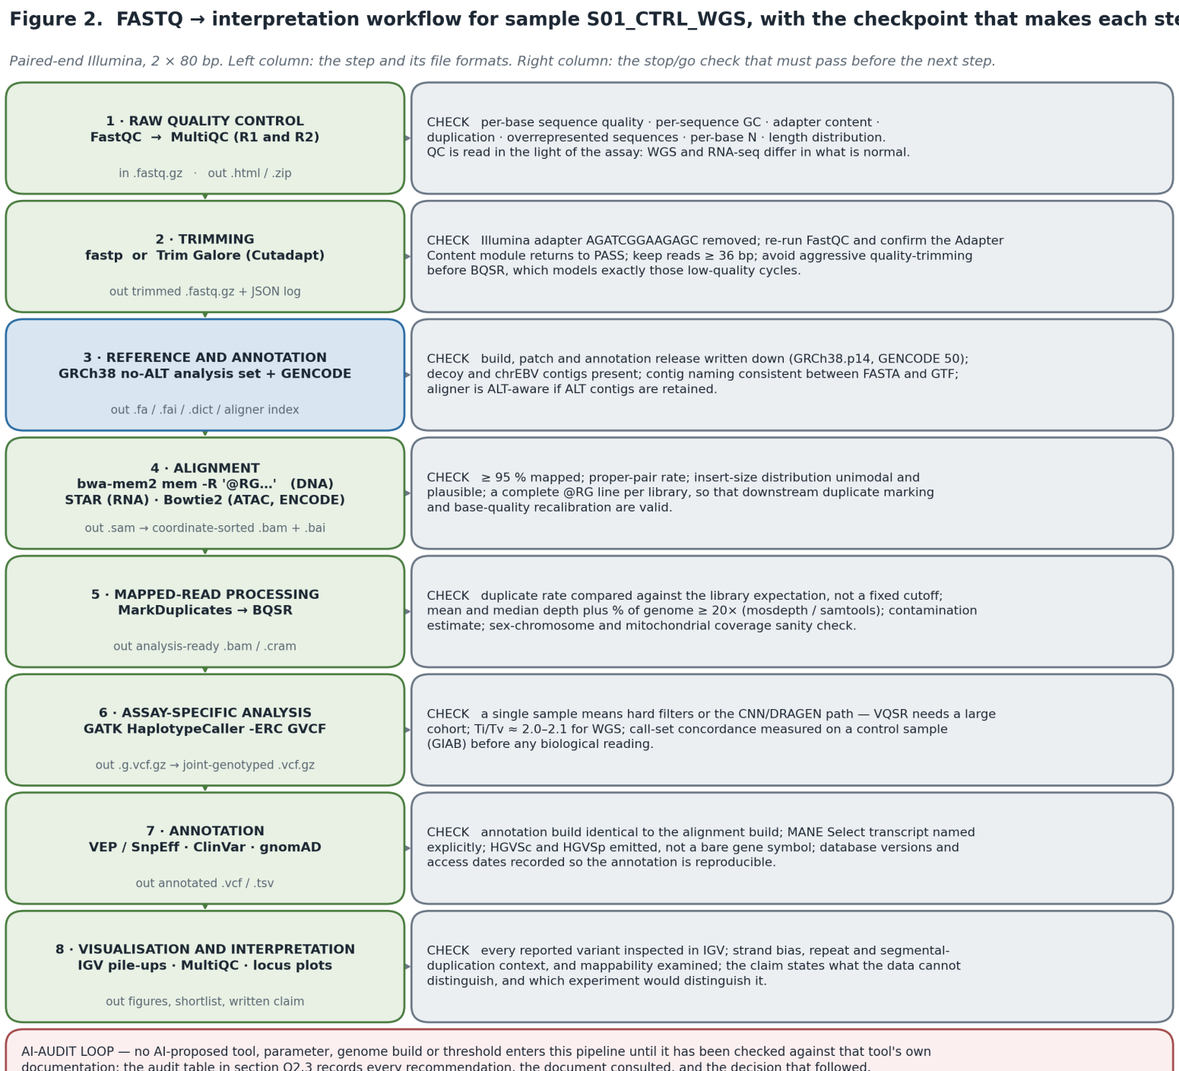
Figure 2. Final workflow. Each step is paired with the checkpoint that must pass before the next step runs; no AI-proposed tool, parameter or genome build enters the pipeline until it has been checked against that tool's own documentation.
The workflow itself is unremarkable — it is close to what any competent laboratory would run. What makes it trustworthy is not the tool list but the four things attached to it: a declared genome build and annotation release, a stated acceptance criterion at every step, a record of which parameters are non-default and why, and an audit trail showing where the AI's recommendation was rejected. A workflow without those four is a set of commands, not a method.
The analyst, not the AI, is responsible for… the genome build and annotation release the results are expressed in; every threshold that was applied and the justification for it; whether the QC pattern actually supports the correction that was made; whether the tool's documentation says what the recommendation claims it says; and the final statement of what the data cannot distinguish. The AI can accelerate every one of those steps and can be wrong in all of them — as it was here on the genome build, on VQSR and on duplicate removal — and a wrong answer that is never checked becomes the analyst's error, not the model's.

Question 3 — Integrate Multi-Omics Evidence into a Regulatory Hypothesis
Problem. A candidate regulatory region lies upstream of Gene Y. ATAC-seq, H3K27ac ChIP-seq/CUT&Tag, DNA methylation, Hi-C/Micro-C and RNA-seq are available from the same biological condition. Is the region a plausible enhancer of Gene Y?

1. My reasoning before AI
I read each layer on its own first, deliberately refusing to let the later layers colour the earlier ones. The discipline that matters here is separating what was measured from what it is taken to mean.
Layer | Direct observation (what was measured) | My interpretation (what I infer) | Missing evidence (what would be needed)
ATAC-seq | A Tn5 insertion peak over the candidate region, higher in the disease condition than in control. | The region is nucleosome-depleted and therefore bindable by transcription factors in this cell state. | Which TF occupies it (footprinting or TF CUT&RUN); whether the difference reflects a change within cells or a change in cell-type composition of the sample.
H3K27ac | An H3K27ac domain flanking the accessible peak, with low H3K4me3 — an enhancer-like rather than promoter-like signature. | The region is in an active chromatin state and has recruited p300/CBP activity. | Whether the acetylation is required: H3K27ac is a correlate, not a demonstrated causal intermediate. Also the IgG/input control and replicate structure, without which the domain is not quantitative.
DNA methylation | CpGs across the region are hypomethylated in the same condition. | Consistent with TF occupancy and an unmethylated, accessible element. | Direction of causality — TF binding commonly causes local hypomethylation rather than following it; and 5mC versus 5hmC, which neither WGBS nor EM-seq distinguishes.
Hi-C / Micro-C | Contact enrichment between the region and the Gene Y promoter, within a single TAD. | The region is spatially positioned to act on the Gene Y promoter rather than on a more distant gene. | Whether the contact is condition-specific or pre-existing architecture; whether it is functionally required, which acute-depletion experiments suggest is often not the case.
RNA-seq | Gene Y is upregulated; other genes within the same TAD are unchanged. | The transcriptional output is specific to Gene Y, which is what an element-specific model predicts. | Direction of causality, and whether an element outside the assayed window is the actual driver. Nascent transcription (PRO-seq/TT-seq) would separate a transcription-rate change from an mRNA-stability change.
Preliminary integrated model (before AI): in the disease condition, the upstream region is an accessible, hypomethylated, H3K27ac-marked element that contacts the Gene Y promoter within its TAD and drives the increase in Gene Y mRNA. Every layer is consistent with this. My reservation, written down before prompting, was that "consistent with" is doing all the work — the five layers are not five independent tests, because accessibility, hypomethylation and acetylation are three readouts of the same underlying event, TF binding. The model therefore rests on perhaps two independent observations, not five.

2. AI-assisted workflow
I asked the model to perform the separation task explicitly, and to name what is missing — the part that is easiest to skip and most costly to skip:
For the locus described below, build a three-column table. Column 1:
DIRECT OBSERVATIONS only -- what the instrument measured, with no
biological language. Column 2: BIOLOGICAL INTERPRETATIONS -- what each
observation is usually taken to mean, and how strong that inference is.
Column 3: MISSING EVIDENCE -- what has not been measured that the
interpretation silently assumes.

LOCUS: upstream region of Gene Y. ATAC peak up in disease; H3K27ac domain
flanking, low H3K4me3; CpG hypomethylation; Hi-C contact with the Gene Y
promoter inside one TAD; Gene Y mRNA up, neighbours unchanged.

Then: (1) state how many INDEPENDENT pieces of evidence this really is,
given that several readouts share one underlying cause; (2) give the single
best alternative model that explains ALL of the observations without the
element regulating Gene Y; (3) design the experiment that distinguishes the
two, and state the result that would falsify MY model, not just support it.
The model produced a usable separation, but I corrected it in two places, recorded below. Its most useful contribution was a blunt statement of the independence problem I had only half-articulated: accessibility, hypomethylation and H3K27ac are three measurements of one event, so the evidence is roughly two independent observations (a chromatin change and a transcriptional change) plus a structural prior.
What the AI classified | Do I agree? | Correction
"H3K27ac domain ⇒ active enhancer" as a biological interpretation with strong support | Partly | Downgraded. Verified against Zhang T. et al. 2020 (Genome Biology 21:45): H3.3-K27R mESCs lose nearly all enhancer H3K27ac yet keep an essentially normal transcriptome. Raisner 2018 argues the opposite from p300/CBP inhibition, so the literature is genuinely split. I record it as evidence of state with contested functional weight, not as evidence of activity.
"Hypomethylation ⇒ the element has been de-repressed" as an interpretation | No — direction reversed | Corrected. The more strongly supported direction is that TF binding drives local demethylation, making hypomethylation a consequence of occupancy rather than its cause. Listed as a consequence-or-cause ambiguity, not as a de-repression event.
"Contact within one TAD ⇒ the element targets Gene Y" as a direct observation | No — category error | Corrected. The direct observation is contact enrichment in a ligation-based assay. Targeting is an interpretation, and one that acute CTCF/cohesin/WAPL/YY1 depletion (Hsieh 2022) shows is not reliably coupled to transcription.
"Neighbouring genes unchanged ⇒ the effect is element-specific" | Yes, with a caveat | Kept, but the caveat is recorded: this only holds for genes inside the assayed window, and it is also the prediction of the bystander model if the shared upstream factor happens to regulate only Gene Y.

3. Verification
- Enhancer chromatin signature: Creyghton et al. 2010 (PNAS 107:21931) and Rada-Iglesias et al. 2011 (Nature 470:279) establish H3K27ac with low H3K4me3 as the active-enhancer signature I relied on — confirming the inference is standard.
- Limit of that signature: Zhang T. et al. 2020 (Genome Biology 21:45) show enhancer function and the transcriptome are largely preserved in H3.3-K27R mESCs lacking enhancer H3K27ac; Raisner et al. 2018 (Cell Reports 24:1722) report the opposite from CBP/p300 bromodomain inhibition. I report both.
- Methylation ambiguity: Vaisvila et al. 2021 (Genome Research 31:1280) for EM-seq; Huang et al. 2010 (PLoS ONE 5:e8888) and Nestor et al. 2010 for the 5mC/5hmC indistinguishability that applies to bisulfite and EM-seq alike. A 2024 Nature Genetics analysis further argues that much of the CpG-methylation–expression correlation is driven by sequence variants, which is a confounder my model would otherwise ignore.
- Contact ≠ regulation: Rao et al. 2017 (Cell 171:305) eliminate loop domains by cohesin degradation with modest transcriptional consequences; Hsieh et al. 2022 (Nature Genetics 54:1919) show enhancer–promoter interactions and transcription are largely maintained after acute loss of CTCF, cohesin, WAPL or YY1; Alexander et al. 2019 (eLife 8:e41769) show enhancer-dependent Sox2 transcription without enhancer proximity.
- Perturbation design: Fulco et al. 2016 (Science 354:769) and 2019 (Nature Genetics 51:1664) for CRISPRi mapping of enhancer–promoter connections; Gasperini et al. 2019 (Cell 176:377) for scale; Lensch et al. 2022 (eLife 11:e75115) for KRAB spreading across a 5 kb spacer and H3K9me3 extending tens of kilobases — the reason my controls are distance-matched.
- Assay standards: ENCODE4 ATAC-seq and histone ChIP-seq standards for the depth, control and replicate structure that make each layer quotable rather than anecdotal.

4. Final conclusion
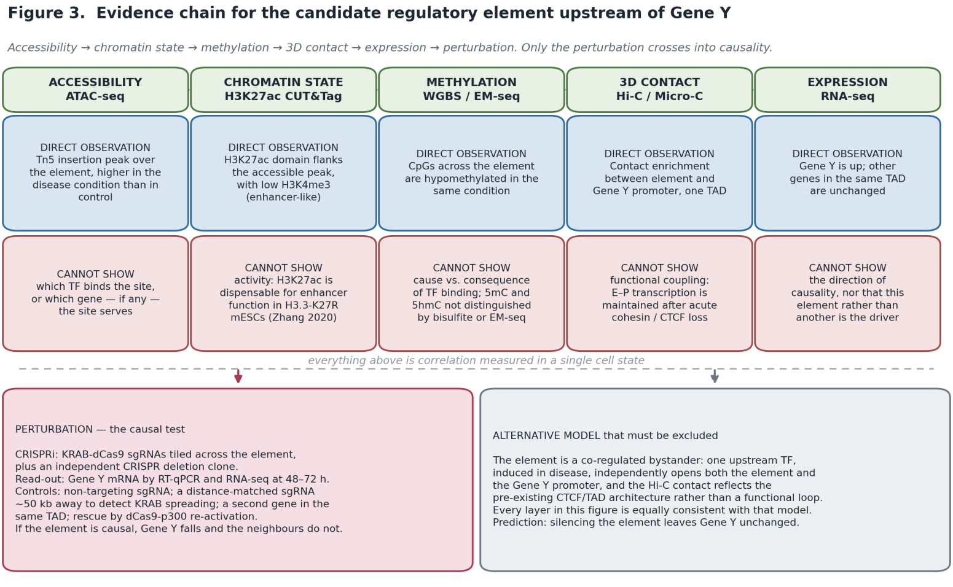
Figure 3. Integrated locus chain: accessibility → chromatin state → methylation → 3D contact → expression → perturbation. Each layer carries its direct observation and the claim it cannot support; the dashed rule marks where correlation ends.

Alternative explanation
The element is a co-regulated bystander. A single transcription factor induced in the disease state binds both the upstream region and the Gene Y promoter independently; the accessibility, hypomethylation and H3K27ac at the element are the footprint of that binding, and the Hi-C contact reflects pre-existing CTCF/TAD architecture that was there before anything changed. Under this model Gene Y is upregulated by the factor acting at its own promoter, and the element contributes nothing. Every observation in the table is equally consistent with it — which is the point. The two models differ in exactly one prediction: silencing the element changes Gene Y under my model and leaves it unchanged under the bystander model.

Functional experiment to distinguish correlation from causality
Design element | Specification
Experiment | CRISPRi (KRAB–dCas9) with sgRNAs tiled across the element, plus an independent CRISPR deletion clone of the same interval as an orthogonal perturbation with a different mechanism.
What is perturbed | The element itself in its native chromatin context — not the sequence in a reporter, and not the loop anchor.
Read-out | Gene Y mRNA by RT-qPCR and RNA-seq at 48–72 h; nascent transcription (PRO-seq) in the deletion clone to confirm the effect is on transcription rate rather than transcript stability.
Expected result if the element is causal | Gene Y falls substantially with multiple independent sgRNAs across the element; the deletion clone reproduces the effect; genes in the same TAD are unaffected.
Expected result if the bystander model is true | Gene Y is unchanged by element silencing and by deletion, despite efficient repression at the element (confirmed by ATAC or H3K9me3 CUT&Tag at the target).
Key controls | Non-targeting sgRNA; a distance-matched sgRNA ~50 kb away to detect KRAB spreading; H3K9me3 CUT&Tag to measure how far the silencing actually spread; a second gene in the same TAD as a specificity read-out; dCas9-p300 re-activation as a rescue; ≥ 3 independent sgRNAs so that a single off-target cannot carry the result.
What would falsify my model | Efficient, confirmed silencing at the element with no change in Gene Y — or a change in Gene Y that is reproduced by the distance-matched control sgRNA, which would mean I measured spreading rather than the element.

~200-word integrated interpretation
Five layers describe this locus, but they are not five independent tests. Accessibility, CpG hypomethylation and H3K27ac are three readouts of one underlying event — transcription-factor occupancy — so the evidence amounts to a chromatin change, a transcriptional change, and a structural prior. Read that way, the case is suggestive rather than strong. Each layer also carries a specific limit: ATAC cannot name the factor or the target gene; H3K27ac marks active enhancers but is dispensable for enhancer function in H3.3-K27R cells, so it reports state, not activity; hypomethylation is more plausibly a consequence of binding than its cause, and neither WGBS nor EM-seq separates 5mC from 5hmC; Hi-C contact largely pre-exists activation and survives acute cohesin or CTCF loss; and the RNA-seq change is the phenotype to be explained, not evidence for a mechanism. A co-regulated-bystander model — one induced factor acting independently at the element and at the promoter, with contact supplied by pre-existing architecture — explains every observation equally well. Because the two models are indistinguishable by any additional correlative assay, the only informative next experiment is perturbation of the element in its native locus, with controls designed to detect KRAB spreading.
The candidate element regulates Gene Y by acting as a condition-specific distal enhancer — transcription-factor occupancy opening and demethylating the element, p300/CBP-associated acetylation of the surrounding chromatin, and a pre-existing intra-TAD contact delivering that activity to the Gene Y promoter to raise its transcription rate — and this can be tested by CRISPRi tiling of the element plus an independent deletion clone, read out as Gene Y nascent and steady-state RNA, with a distance-matched control sgRNA and H3K9me3 CUT&Tag to prove the effect is the element and not spreading; unchanged Gene Y despite confirmed silencing would falsify the model in favour of the co-regulated-bystander alternative.

Question 4 — AI-Assisted Variant Prioritization
Data. data/variants_q4.tsv, twelve synthetic variants with CHROM, POS, REF, ALT, FILTER, DP, GQ, AF, GENE, CONSEQUENCE, CLINVAR_SIG, CLINVAR_ID and NOTE. The package README states that gene names, ClinVar-style IDs and coordinates are illustrative. I treat the NOTE column as a hint to be tested, not as a ranking, and — as shown in §4.3 — I treat the CONSEQUENCE and CLINVAR columns as claims to be re-derived rather than as evidence.

1. My reasoning before AI
I defined the filter logic before writing or requesting any code, and ordered it so that the cheapest and most decisive criteria run first. The premise I am filtering under is explicit, because it determines the thresholds: a rare, highly penetrant germline disease allele in a single sequenced individual.
Criterion | Rule / threshold | Rationale
FILTER | Keep FILTER == PASS only | A variant the caller distrusts is not a biological observation. This is the cheapest discriminator and it removes the most dangerous class of false lead — a technically wrong call in a famous gene.
Depth (DP) | DP ≥ 20 | Below ~20× a heterozygous site is regularly under-sampled, and the genotype rather than the position becomes unreliable. 20× is the conventional floor for confident germline heterozygote calling in WGS.
Genotype quality (GQ) | GQ ≥ 30 | GQ 30 corresponds to a ~1-in-1,000 probability that the genotype call is wrong. Lower values mean the caller could not distinguish the genotypes, which is a different failure from low depth and must be filtered separately.
Allele frequency (AF) | AF ≤ 0.001 | Under a penetrant rare-disease premise, an allele carried by more than ~1 in 1,000 people would produce far more disease than is observed. This threshold is a statement about the disease model, not a universal constant — for a common complex trait it would be wrong.
Consequence | Keep stop_gained, frameshift, splice_acceptor/donor, missense; route intergenic and intronic to a separate non-coding queue rather than discarding them | Coding and canonical-splice consequences have interpretable mechanisms. Non-coding variants are not uninterpretable — they are uninterpretable with this evidence, so they are parked, not deleted.
Clinical annotation | Rank by ClinVar label after filtering, never filter on it | Filtering on ClinVar would make the analysis circular — it would only ever rediscover what is already known, and would drop every novel pathogenic allele. It is a ranking signal at most.
Gene / biology | Considered last, and stated as a bias | Recognising a famous gene symbol is the strongest source of confirmation bias in this exercise. Applied after the objective filters, and only to frame the hypothesis.
Hard excludes | FILTER ≠ PASS; DP < 20 or GQ < 30; AF above the rare-disease ceiling | —
Soft ranks (kept, down-weighted) | Conflicting_interpretations_of_pathogenicity; Uncertain_significance; variants in regions of known mapping difficulty (MHC, segmental duplications) | —

2. AI-assisted workflow
Plan-first again: thresholds fixed by me, code requested afterwards, with the model asked to attack the thresholds rather than implement them silently.
STAGE 1 -- CRITIQUE MY FILTER PLAN. Do not write code yet.

Premise: one individual, suspected rare penetrant germline disease.
Table columns: CHROM POS REF ALT FILTER DP GQ AF GENE CONSEQUENCE
CLINVAR_SIG CLINVAR_ID NOTE
My filters, in order: FILTER==PASS; DP>=20; GQ>=30; AF<=0.001;
consequence in {stop_gained, frameshift, splice_acceptor, splice_donor,
missense}; rank by ClinVar label; never filter ON ClinVar.

1. Which threshold is most likely to discard a true positive, and why?
2. Which columns in this table are ASSERTIONS that I should re-derive
rather than trust? Say exactly how to re-derive each one.
3. What information is MISSING from these columns that a real
prioritisation would require?
4. Is my ordering of filters optimal for cost and information?

STAGE 2 -- then write R (readr/dplyr) implementing MY thresholds, with the
cascade count after each step and the reason each variant was dropped.

STAGE 3 -- after I give you my ranking, argue the strongest case that my
top variant is a FALSE LEAD. Be specific and adversarial.
Answer 2 is what redirected the whole question. The model named CONSEQUENCE, CLINVAR_SIG and CLINVAR_ID as assertions to be re-derived from the coordinates — and when I actually did that, three of them turned out to be wrong. Answer 3 named the missing column that matters most: allelic depth / variant allele fraction, without which germline heterozygosity cannot be separated from somatic mosaicism.
The completed R filter script (the supplied starter/q4_filter_starter.R with my thresholds filled in) is in Appendix B, together with the exact console output of the run. R was not available in my execution environment, so the identical logic was executed as a line-by-line transcription in Python; both the R script and the executed transcription are included so the result can be reproduced either way.

3. Verification

3.1 Filter cascade as executed
Step | n remaining | Excluded, with reason
Input | 12 | —
FILTER == PASS | 10 | MSH2 chr2:47,641,560 (LowQual) — a stop_gained labelled Pathogenic, which is exactly the kind of variant a quality filter exists to catch before it becomes a finding; HLA-A chr6:29,942,857 (FAIL) — and independently untrustworthy, since short reads map poorly across the MHC.
DP ≥ 20 and GQ ≥ 30 | 9 | MECP2 chrX:153,870,000 (DP = 5, GQ = 20) — a frameshift called on five reads. Note this one passed FILTER, so depth and genotype quality had to be filtered separately from FILTER to catch it.
AF ≤ 0.001 | 6 | F5 chr1:169,519,049 (AF 0.42); ATM chr11:108,323,000 (AF 0.18); chr4:88,000,000 intronic (AF 0.35) — all far too common for a penetrant rare-disease allele.
Protein- or splice-impacting consequence | 4 | CFTR chr7:117,199,644 synonymous; chr8:128,750,000 intergenic with no gene assigned — moved to the non-coding queue rather than discarded.
Shortlist (n = 4), ordered by ClinVar label then AF:
CHROM | POS | REF>ALT | DP | GQ | AF | GENE | CONSEQUENCE (as supplied) | CLINVAR_SIG (as supplied)
chr17 | 7,673,803 | G>A | 80 | 99 | 1e-5 | TP53 | splice_acceptor_variant | Pathogenic
chr12 | 25,398,284 | C>A | 58 | 91 | 1.5e-4 | KRAS | missense_variant | Conflicting interpretations
chr13 | 32,316,461 | C>T | 60 | 90 | 1e-4 | BRCA2 | missense_variant | Uncertain significance
chr19 | 11,200,200 | C>T | 40 | 88 | 2e-4 | LDLR | missense_variant | Likely benign

3.2 Independent re-annotation — the step that changed the answer
Rather than accept the table's own CONSEQUENCE and CLINVAR columns, I re-derived them from the coordinates using Ensembl (REST lookup and VEP, GRCh38, release 116) and ClinVar directly. Three of the four shortlisted rows did not survive that check, and one of the excluded rows turned out to be internally contradictory.
Variant | What the table asserts | What the primary source returns | Consequence for my ranking
TP53 chr17:7,673,803 G>A | splice_acceptor_variant; Pathogenic; VCV000012345 | Ensembl VEP (GRCh38): missense_variant, TP53 p.Arg273Cys on MANE ENST00000269305, rs121913343, SIFT deleterious; ClinVar classifications across submitters include pathogenic and likely pathogenic. Separately, VCV000012345 is not a TP53 record at all — it is TNFRSF1A NM_001065.4:c.295T>A (p.Cys99Ser), associated with TRAPS. | Still ranked first, but for a different reason and with a different mechanism. A DNA-contact hotspot missense is not a splice defect, and the accession supplied as evidence points at an unrelated gene.
BRCA2 chr13:32,316,461 C>T | missense_variant; Uncertain_significance | Ensembl VEP (GRCh38): start_lost on MANE ENST00000380152 (p.Met1?), i.e. loss of the initiator codon. | Promoted to rank 2. The supplied label understates the predicted impact; a start-loss in a loss-of-function gene is a far stronger candidate than a VUS missense.
KRAS chr12:25,398,284 C>A | missense_variant in KRAS; Conflicting interpretations | Ensembl: KRAS on GRCh38 spans chr12:25,205,246–25,326,473, so this position is outside the gene and VEP returns intergenic_variant. The coordinate is the GRCh37 position of the KRAS codon-12 hotspot. | Dropped from consideration. Under the declared build it is intergenic; under GRCh37 it is a canonical somatic oncogene hotspot, which belongs to a tumour analysis, not a germline one.
LDLR chr19:11,200,200 C>T | missense_variant in LDLR; Likely_benign | Ensembl: LDLR on GRCh38 spans chr19:11,089,418–11,133,830; this position lies outside the gene and corresponds to the GRCh37 LDLR interval. | Dropped — already the lowest-ranked by ClinVar label, and its coordinate does not resolve to LDLR in the stated build.
F5 chr1:169,519,049 G>A (excluded at the AF step) | missense_variant; Benign; AF = 0.42 | chr1:169,519,049 is the GRCh37 coordinate of rs6025, Factor V Leiden (F5 c.1601G>A, p.Arg534Gln); on GRCh38 that variant sits at chr1:169,549,811, and the supplied position, read under GRCh38, returns only an F5 intron_variant from VEP. ClinVar VCV000000642 classifies it as Pathogenic / risk factor for thrombophilia — not Benign — and gnomAD gives an allele frequency of ~0.017–0.022, not 0.42. | Confirms the exclusion for the wrong reason. It was excluded for being common; verification shows the row is internally inconsistent in build, in classification and in frequency. It is also the clearest demonstration that AF alone is an unsafe filter: Factor V Leiden is both common and clinically actionable.
Whole table | One coherent coordinate system (implied) | Spot-checks resolve TP53, BRCA2, MSH2, ATM and HLA-A positions inside their genes on GRCh38, while CFTR, KRAS, LDLR and F5 positions correspond to GRCh37 intervals, and chrX:153,870,000 falls inside MECP2 in neither build. No genome build is declared anywhere in the file. | No ranking derived from this table can be reported without first re-calling or lifting over to a single declared build. This is the single most important finding of the question.
Sources used for verification (≥ 2 required; six were used): Ensembl REST lookup and Ensembl VEP (GRCh38, release 116); NCBI ClinVar record pages (VCV000000642, VCV000012345); dbSNP (rs6025, rs121913343); gnomAD v4.1.1 allele frequencies as reported on the ClinVar record; NCBI GRC assembly documentation for build coordinates; and the ACMG/AMP 2015 guideline with the ClinGen SVI specifications for the classification framework.

3.3 Evidence ladder for the top variant
Stage | Content
Known evidence (database and data facts) | chr17:7,673,803 G>A passes FILTER at DP 80 and GQ 99, with AF 1e-5 in the supplied table. Independently re-annotated on GRCh38, it is TP53 p.Arg273Cys (rs121913343) on MANE transcript ENST00000269305; SIFT scores it deleterious; ClinVar carries pathogenic and likely-pathogenic submissions for this variant, and it is a recurrent COSMIC hotspot. R273 is one of the residues that contacts DNA directly in the p53 DNA-binding domain.
Computational inference | Substitution of a DNA-contacting arginine is predicted to abolish sequence-specific DNA binding without destabilising the protein fold, i.e. a contact mutant rather than a structural mutant. The technical metrics give no reason to suspect a calling artefact; the quality of this call is the best in the table.
Scientific hypothesis | This allele reduces or abolishes p53 sequence-specific transactivation, impairing the p53-dependent DNA-damage response. If it is germline, it is a Li-Fraumeni-type cancer-predisposition hypothesis; if it is somatic or clonal, it is a tumour-biology observation that happens to appear in a germline-framed file. The data as supplied cannot distinguish those two.
Required experiment | First, orthogonal confirmation and germline proof: Sanger or a second chemistry, plus sequencing of a non-haematopoietic tissue (cultured fibroblasts or buccal DNA) at high depth, with allelic fraction reported — a germline heterozygote sits near 0.5, clonal haematopoiesis sits well below it. Then functional evidence: a p53 transactivation reporter assay for the R273C allele against wild-type and a known-null control, and, where relevant tissue exists, p21/MDM2 target-gene induction after DNA damage. Formal classification follows under ACMG/AMP with the ClinGen SVI specifications, not from the label shipped in the table.

3.4 False-lead critique
I asked the model for the strongest reasons my top variant could be a false lead, then decided which concerns are scientifically serious and which are not.
Concern raised | Serious? | My judgement
R273C is overwhelmingly a somatic hotspot; this could be clonal haematopoiesis or tumour-in-normal contamination rather than a germline variant | Yes — the decisive concern | This is the strongest objection and it cannot be answered with the data provided, because the table has no allelic-depth or VAF column. A germline heterozygote and a 10% clonal population look identical in DP, GQ and AF as tabulated. Resolving it is the first item in my required-experiment list.
The supplied CONSEQUENCE (splice_acceptor_variant) is wrong under GRCh38 | Yes | Verified wrong. It does not remove the variant from the shortlist, but it does mean the mechanism I would have written down from the table — a splicing defect — is not the mechanism the sequence supports. Any downstream assay designed from that label would have been the wrong assay.
The supplied CLINVAR_ID does not correspond to this variant | Yes | Verified: VCV000012345 is a TNFRSF1A record. The identifier is a placeholder, and the README says so, but in a real submission this is the class of error that makes a report unciteable. It also means the "Pathogenic" label in the table is unsourced as given.
AF = 1e-5 is asserted without a named frequency database or population | Yes, moderately | A single global AF with no population breakdown cannot support a rarity argument. gnomAD v4.1.1 reports per-population frequencies for a reason: an allele at 1e-5 globally may be far more common in one ancestry group, which changes the prior substantially.
The whole table mixes genome builds | Yes | Verified across several rows. Any coordinate-based claim from this file is provisional until it is re-called or lifted over to one declared build.
TP53 is a famous gene, so the ranking may be confirmation bias | Partly | A fair criticism of the process, but here the variant also has the best technical metrics in the table and the strongest independent re-annotation evidence, and it was reached by objective filters applied before gene identity was considered. I record the bias rather than deny it.
Synthetic data means none of this is real | No — not scientifically relevant | True but not a criticism of the reasoning. The README states the data are teaching synthetics; the exercise is whether the inference chain is sound, and the inference chain is what I am accountable for.

4. Final conclusion
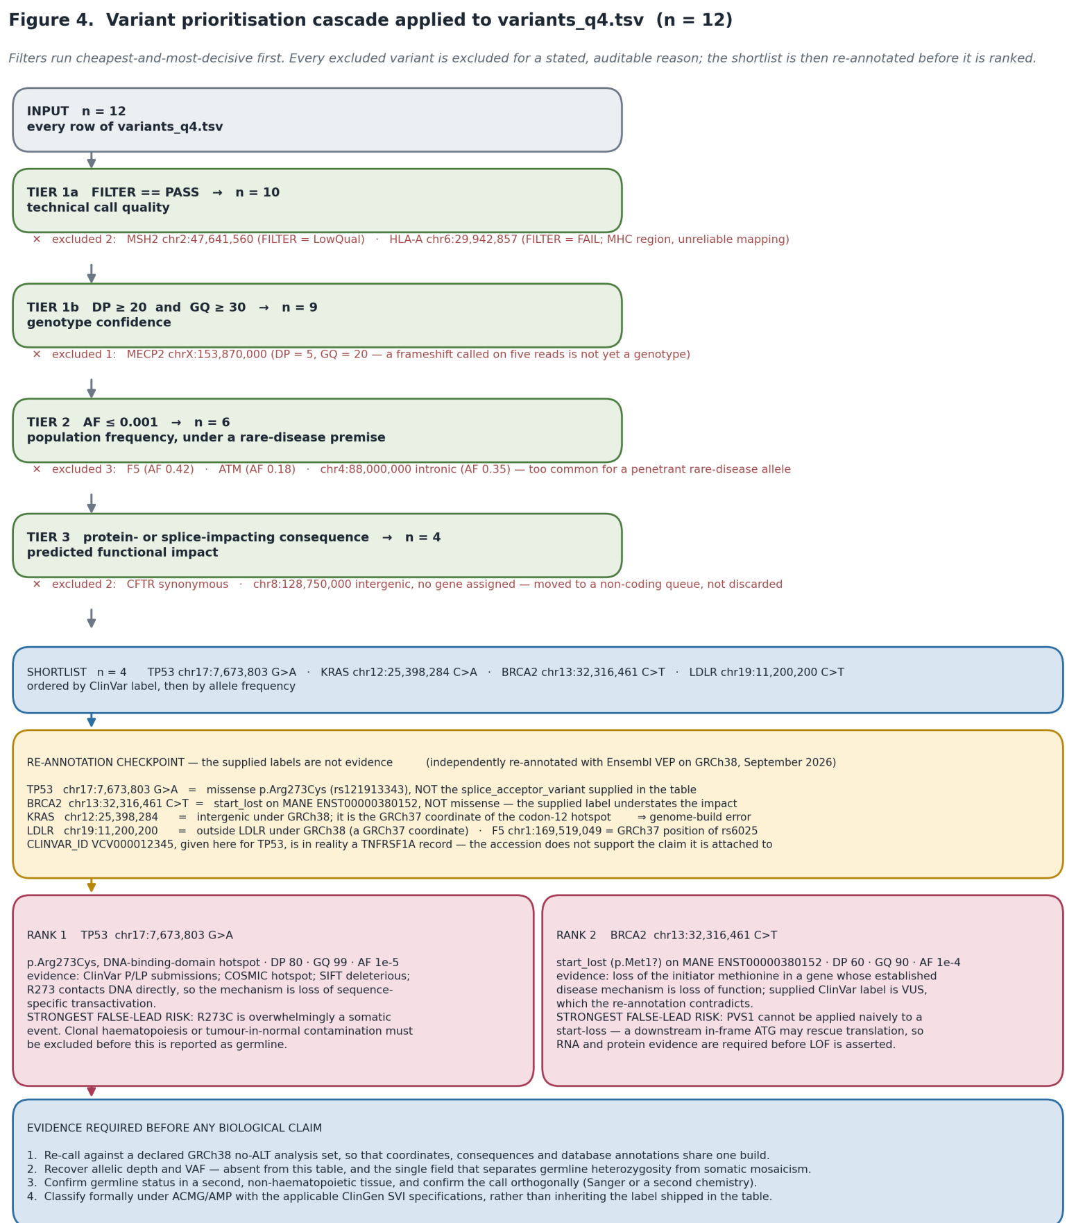
Figure 4. Prioritisation workflow: filter cascade with every exclusion reasoned, an independent re-annotation checkpoint before ranking, the two ranked candidates with their strongest false-lead risks, and the evidence required before any biological claim.

~200-word final interpretation
Known evidence: after quality, frequency and consequence filters, four of twelve variants survive, and chr17:7,673,803 G>A has the best technical metrics in the file (DP 80, GQ 99, PASS). Independent re-annotation on GRCh38 identifies it as TP53 p.Arg273Cys, rs121913343 — a recurrent DNA-contact hotspot with pathogenic ClinVar submissions — not the splice-acceptor variant the table asserts; the same check promotes BRCA2 chr13:32,316,461 from "missense VUS" to start_lost. Computational inference: substituting a DNA-contacting arginine should abolish sequence-specific binding while leaving the fold intact, giving a defective p53 that is expressed rather than absent. Scientific hypothesis: this allele impairs p53-dependent transactivation and the DNA-damage response, which in the germline would be a cancer-predisposition mechanism. The hypothesis is fragile in one specific way: R273C is overwhelmingly somatic, and the table lacks the allelic-depth field that would separate a germline heterozygote from clonal haematopoiesis or tumour-in-normal contamination. Required experiment: confirm germline status by deep sequencing of a non-haematopoietic tissue with VAF reported, confirm the call orthogonally, then measure p53 transactivation for R273C against wild-type and null controls, and classify formally under ACMG/AMP with ClinGen SVI specifications.
Variant chr17:7,673,803 G>A (TP53, p.Arg273Cys, rs121913343) may influence p53-dependent transcriptional control of the DNA-damage response by affecting sequence-specific DNA binding at a DNA-contacting residue of the p53 DNA-binding domain — not, as the supplied table states, by disrupting a canonical splice acceptor; this can be tested by deep resequencing of a non-haematopoietic tissue with allelic fraction reported to establish that the variant is germline rather than clonal, followed by a p53 transactivation reporter assay of the R273C allele against wild-type and null controls, with p21/MDM2 induction after DNA damage as the endogenous read-out, and formal ACMG/AMP classification applied to the result.

Appendix A — Summary of where verification changed the answer
Q | What AI or the supplied data asserted | What verification established | Effect on the report
Q1 | H3K27ac demonstrates enhancer activity | Zhang T. 2020 (Genome Biology): enhancer function and transcriptome largely preserved without enhancer H3K27ac; Raisner 2018 argues the opposite | H3K27ac reported as chromatin state with contested functional weight, not as activity
Q1 | H3K4me1 is a narrow mark like H3K27ac | ENCODE4 classes H3K4me1 as broad (45 M usable fragments) and H3K27ac as narrow (20 M) | Depth requirements corrected in the design
Q1 | 3D contact evidences regulation | Rao 2017; Hsieh 2022; Alexander 2019 | Micro-C demoted to a targeting heuristic
Q2 | Use GRCh37/hg19; use ALT contigs; switch to T2T-CHM13 | GATK build guidance; Heng Li on no-ALT analysis sets; Ek 2025 on the T2T annotation gap | GRCh38 no-ALT analysis set adopted and declared
Q2 | Filter with VQSR | GATK: VQSR requires a large cohort; hard filtering documented for small callsets | Hard filtering / single-sample path
Q2 | Deduplicate at the FASTQ stage | FastQC duplication module reads only the first 100,000 reads, truncated to 50 bp | MarkDuplicates after alignment instead
Q4 | chr17:7,673,803 is a splice_acceptor_variant | Ensembl VEP GRCh38: TP53 p.Arg273Cys missense, rs121913343 | Mechanism and proposed experiment changed
Q4 | chr13:32,316,461 is a missense VUS | Ensembl VEP GRCh38: start_lost on MANE ENST00000380152 | Promoted to rank 2
Q4 | CLINVAR_ID VCV000012345 supports the TP53 call | ClinVar: VCV000012345 is TNFRSF1A c.295T>A | Label treated as unsourced
Q4 | F5 chr1:169,519,049 is Benign with AF 0.42 | GRCh37 coordinate of rs6025 (Factor V Leiden); ClinVar VCV000000642 Pathogenic/risk factor; gnomAD ~0.017–0.022 | Exclusion upheld, but the row shown to be internally inconsistent
Q4 | The table uses one coordinate system | Coordinates resolve variously under GRCh38 and GRCh37; no build is declared | All coordinate-based claims marked provisional pending re-call

Appendix B — Q4 filter code and executed output
The supplied skeleton starter/q4_filter_starter.R with my thresholds and ranking logic filled in:
library(readr); library(dplyr)

variants <- read_tsv(file.path("..","data","variants_q4.tsv"),
comment = "#", show_col_types = FALSE)

# --- my thresholds (see Q4 section 1 for the rationale of each) ---
min_dp <- 20 # confident germline heterozygote calling
min_gq <- 30 # ~1-in-1000 chance the genotype call is wrong
max_af <- 0.001 # rare penetrant disease premise, NOT a universal constant
require_pass <- TRUE

impact_consequences <- c("stop_gained", "frameshift_variant",
"splice_acceptor_variant", "splice_donor_variant",
"missense_variant")

filtered <- variants %>%
filter(FILTER == "PASS",
DP >= min_dp, GQ >= min_gq, AF <= max_af,
CONSEQUENCE %in% impact_consequences)

# ClinVar is used to RANK, never to filter (filtering on it would be circular)
sig_rank <- c(Pathogenic = 1, Likely_pathogenic = 2,
Conflicting_interpretations_of_pathogenicity = 3,
Uncertain_significance = 4, Likely_benign = 5, Benign = 6)

prioritized <- filtered %>%
mutate(rank_sig = sig_rank[CLINVAR_SIG]) %>%
arrange(rank_sig, AF)

print(prioritized); write_tsv(prioritized, "q4_shortlist.tsv")

# NOTE: the shortlist is NOT the answer. CONSEQUENCE and CLINVAR_* are
# assertions in the input file; they are re-derived from CHROM/POS/REF/ALT
# with Ensembl VEP on a declared build before any variant is ranked.
R was not installed in the execution environment, so the identical logic was run as a line-by-line transcription in Python (pandas). Console output:
=== CASCADE ===
Input table n=12
Tier 1a FILTER==PASS n=10 dropped: HLA-A, MSH2
Tier 1b DP>=20 & GQ>=30 n= 9 dropped: MECP2
Tier 2 AF<=0.001 n= 6 dropped: ., ATM, F5
Tier 3 protein/splice-impacting consequence n= 4 dropped: .(intergenic),
CFTR(synonymous)

=== SHORTLIST ===
CHROM POS REF ALT DP GQ AF GENE CONSEQUENCE CLINVAR_SIG
chr17 7673803 G A 80 99 0.00001 TP53 splice_acceptor_variant Pathogenic
chr12 25398284 C A 58 91 0.00015 KRAS missense_variant Conflicting
chr13 32316461 C T 60 90 0.00010 BRCA2 missense_variant Uncertain
chr19 11200200 C T 40 88 0.00020 LDLR missense_variant Likely_benign

=== EXCLUDED, WITH REASON ===
F5 chr1:169519049 AF=0.42
CFTR chr7:117199644 consequence=synonymous_variant
MSH2 chr2:47641560 FILTER=LowQual; DP=8; GQ=12
HLA-A chr6:29942857 FILTER=FAIL
. chr8:128750000 consequence=intergenic_variant
ATM chr11:108323000 AF=0.18
MECP2 chrX:153870000 DP=5; GQ=20
. chr4:88000000 AF=0.35; consequence=intron_variant

